

Topic : ONLINE HELP DESK FOR UNIVERSITY STUDENTS

Group no : PRO_02

Campus : Malabe

Submission Date : 20/05/2022

We declare that this is our own work and this Assignment does not incorporate without acknowledgment any material previously submitted by anyone else in SLIIT or any other university/Institute. And we declare that each one of us equally contributed to the completion of this Assignment.

|  |  |  |
| --- | --- | --- |
| **Registration No** | **Name** | **Contact Number** |
| IT19138282 | Edirisinghe O.S. | 0702416582 |
| IT19149004 | Wijerathne M.K.N.B. | 0702438663 |
| IT19236056 | Siriwardana A.W.A.S.K.K. | 0702682489 |
| IT20098582 | Nissanka L.N.A.T.A. | 0769097706 |
|  |  |  |

Classes identified

* User
* Course
* Language
* Lesson

CRC Cards

Course

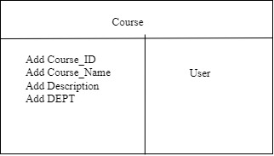

User

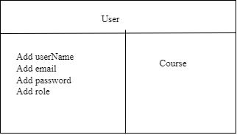

Language

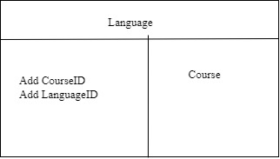

Lesson

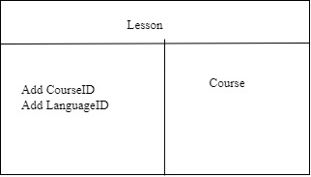

UML Diagram

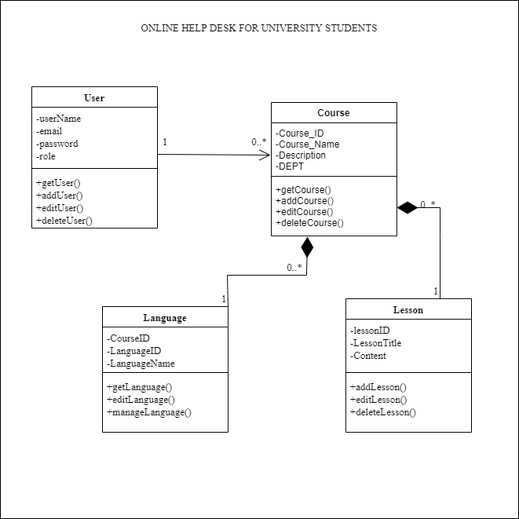

Git repo